ព្រះរាជាណាចក្រកម្ពុជា

ជាតិ​ សាសនា ព្រះមហាក្សត្រ

Institute of technology of Cambodia

Department of Information and communication Engineering

The lesson taking about using File IO in c++

TP: 18 file IO

TP: Algorithm and Programming ll

Lecturer: BOU CHANNA

Student: VEN THON

ID: e20191250

Group: I3-GIC-C

Year: 2022-2023

Contents

Problem1: 3

Problem2: 5

Problem3: 6

# 

# Problem1:

Createastructureofcustomer (customerID, name, gender, customer type (VIP, guest, normal), phone number).

a.Createan array of customer, say myCustomers.

b.Ask a user to input information of 10 customers and store in myCustomers

c.Write data from myCustomersinto a file named ListCustomer.txt

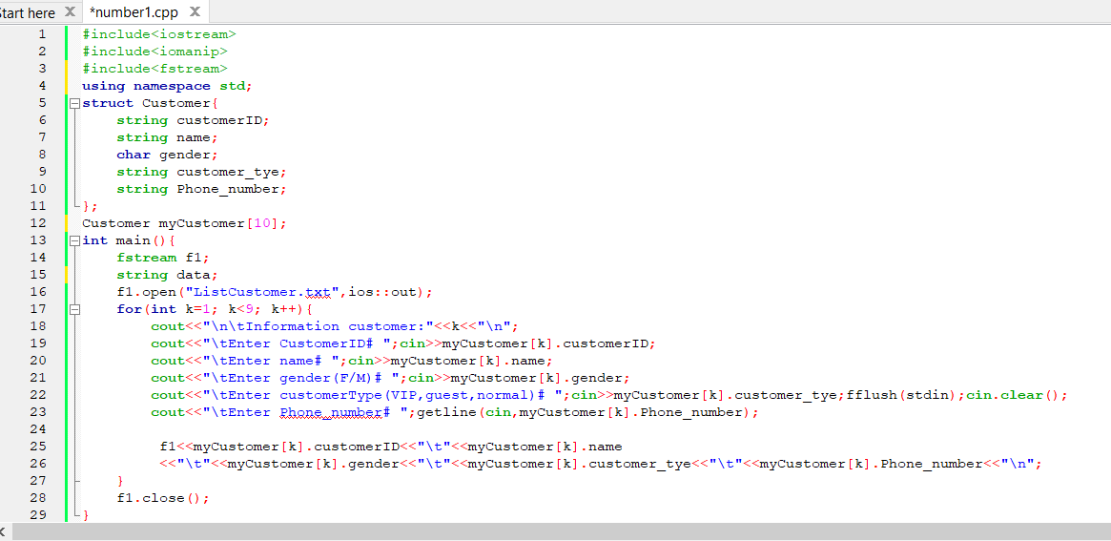

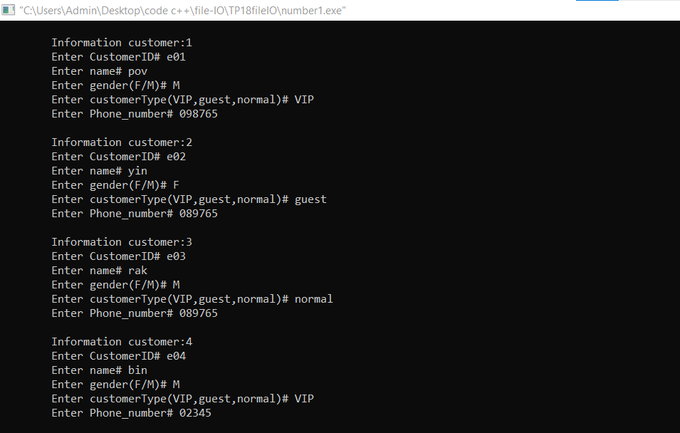

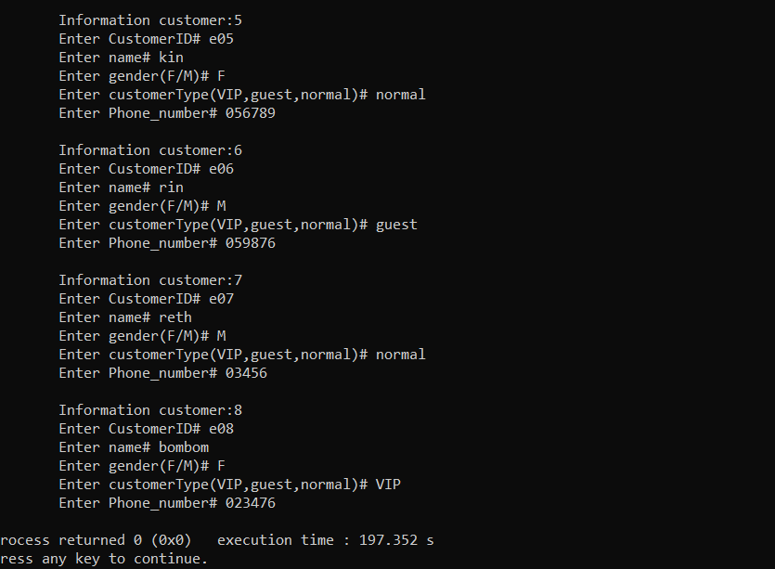

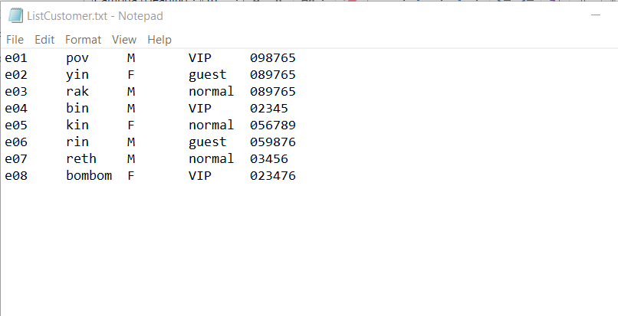

# Problem2:

Write a program to store information of students. A student has name, age and email.

a)Get the data from file and store to variables in your program

b)Display the data

c)Add information of 3 more students

d)Store those data into a file then close the programProgram.cData.txtFILE *f

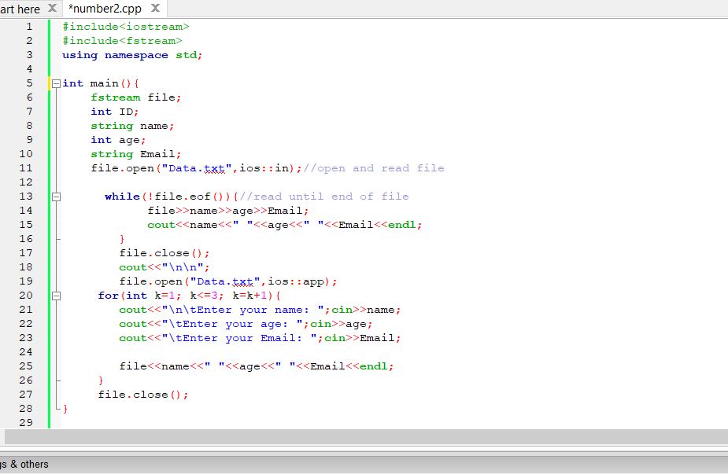

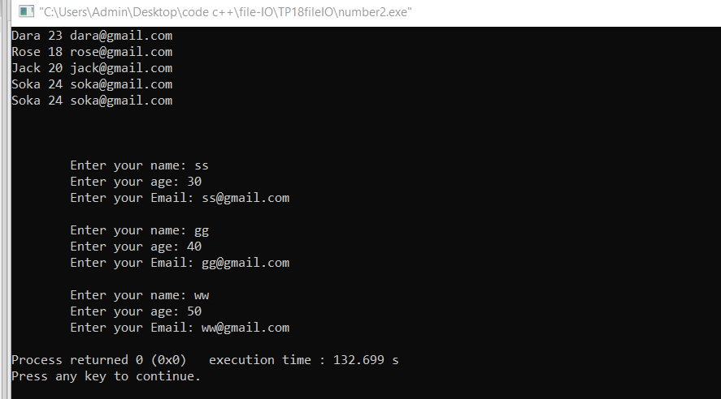

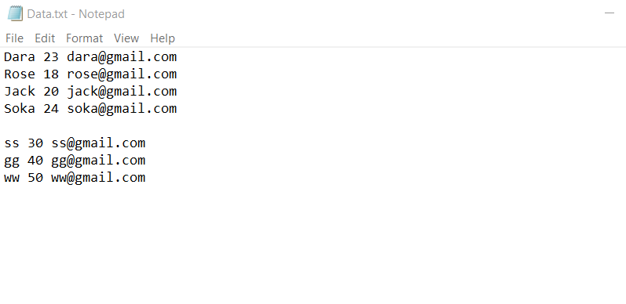

# 

# Problem3:

Write a program to create 1000 txt files in a folder located in your computer D:TP18MultipleFilesYourName. Each file contains sequence number as follows:

▪File n= store numbers from n to 10*n

▪Examples:

▪File1 = contains numbers 1, 2, 3, 4, 5, ..., 10

▪File2=contains numbers 2, 3, 4, ... 20

▪...............................

▪Filen=contains numbers n, n+1, n+2, ..., 10*n

